Day: 19 (06-11-2026) | Power BI performance analyzer | Documented By:
Task – 4 | Power BI performance analyzer | Sujit T K

- Look for ‘Optimize’ tab and click on ‘Performance Analyzer’
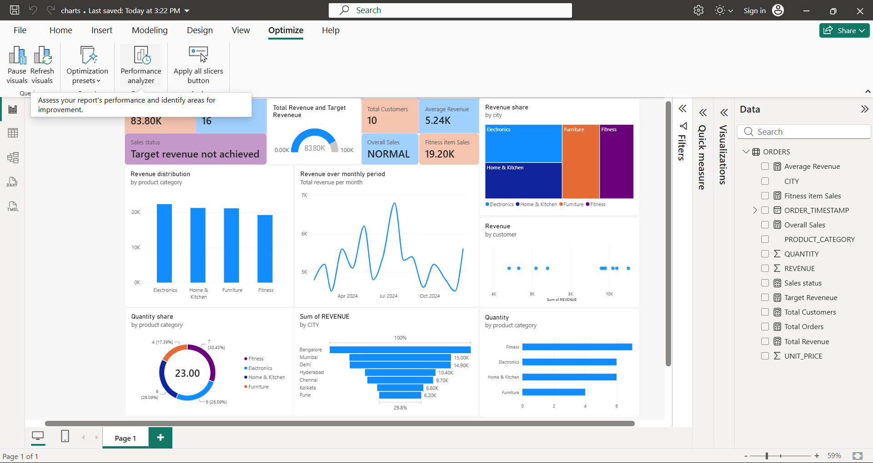

- Select ‘start recording’ and hit on ‘Refresh visuals’ once the recording is started.
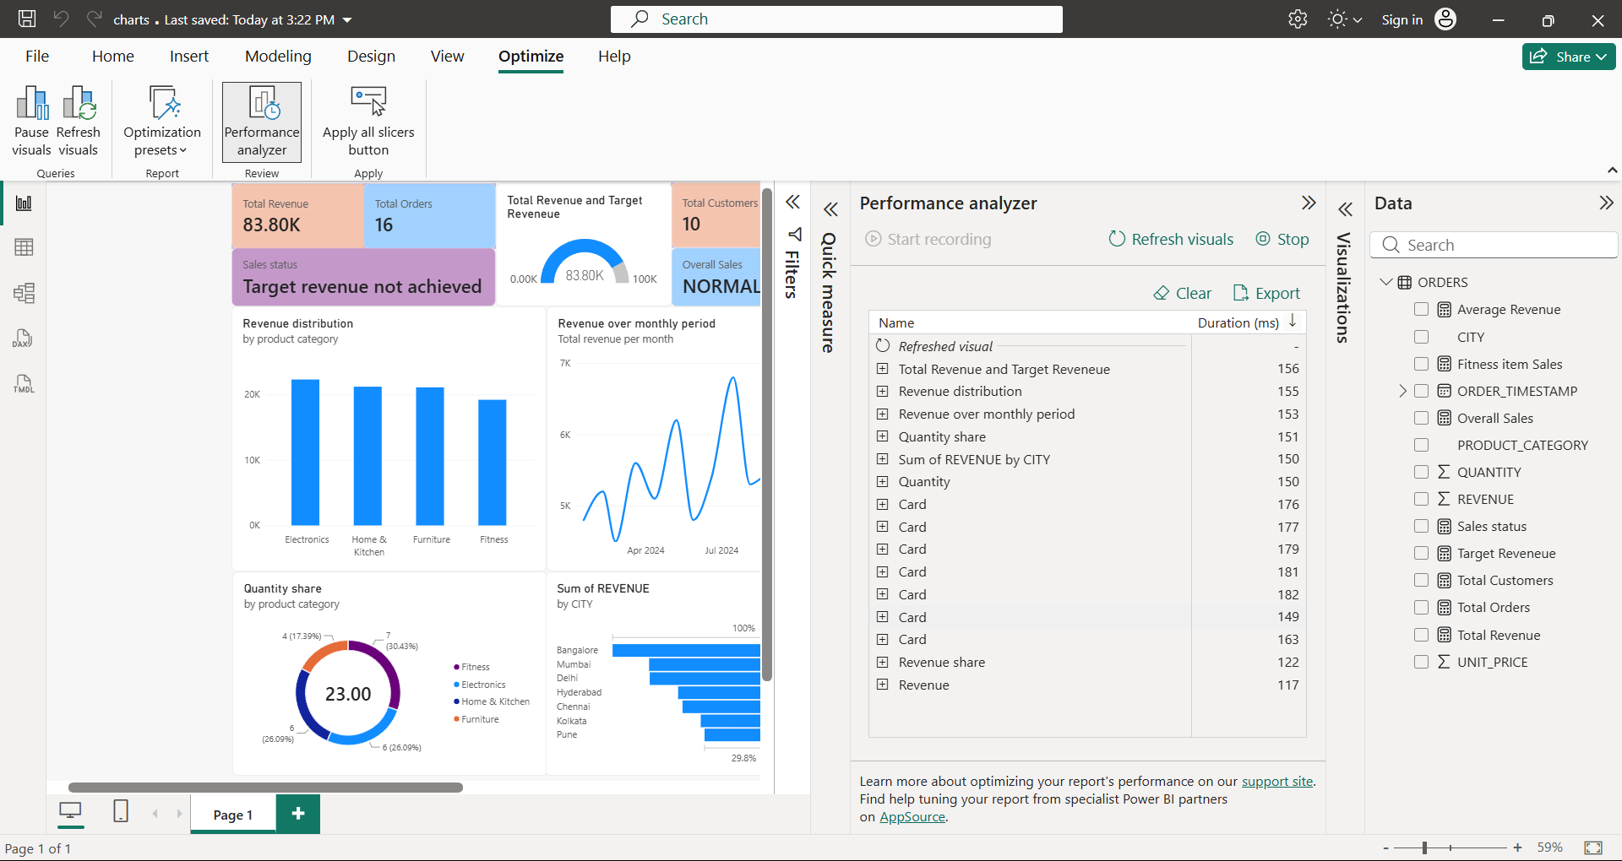

- Click on ‘Stop’ button to turn off recording. Now analyse the time taken for each component.
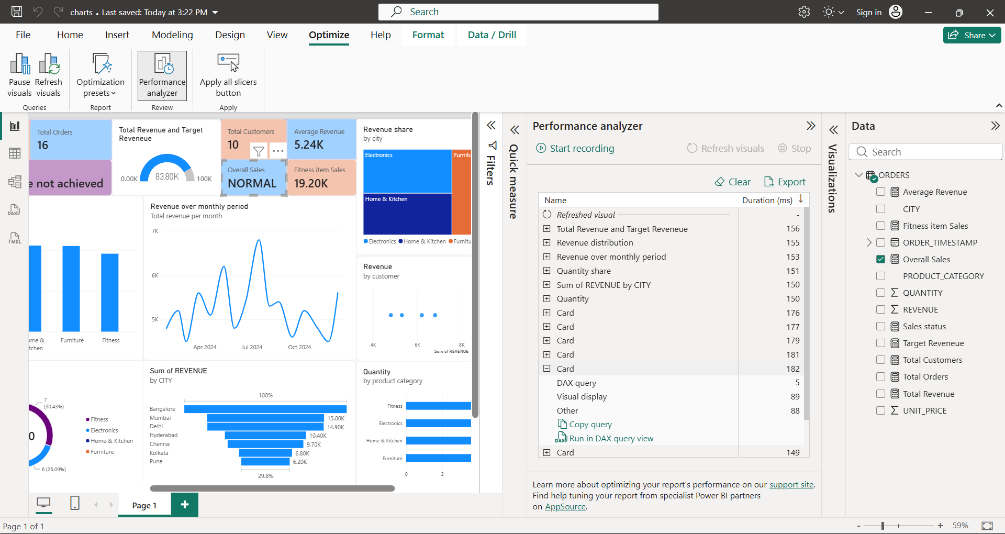
Now click on the component that took maximum time (182 ms in this case). It will highlight the component (card here) and shows step-by-step time consumption.
- Optimize the DAX measure formula or adjust the size of the display to reduce compute time.
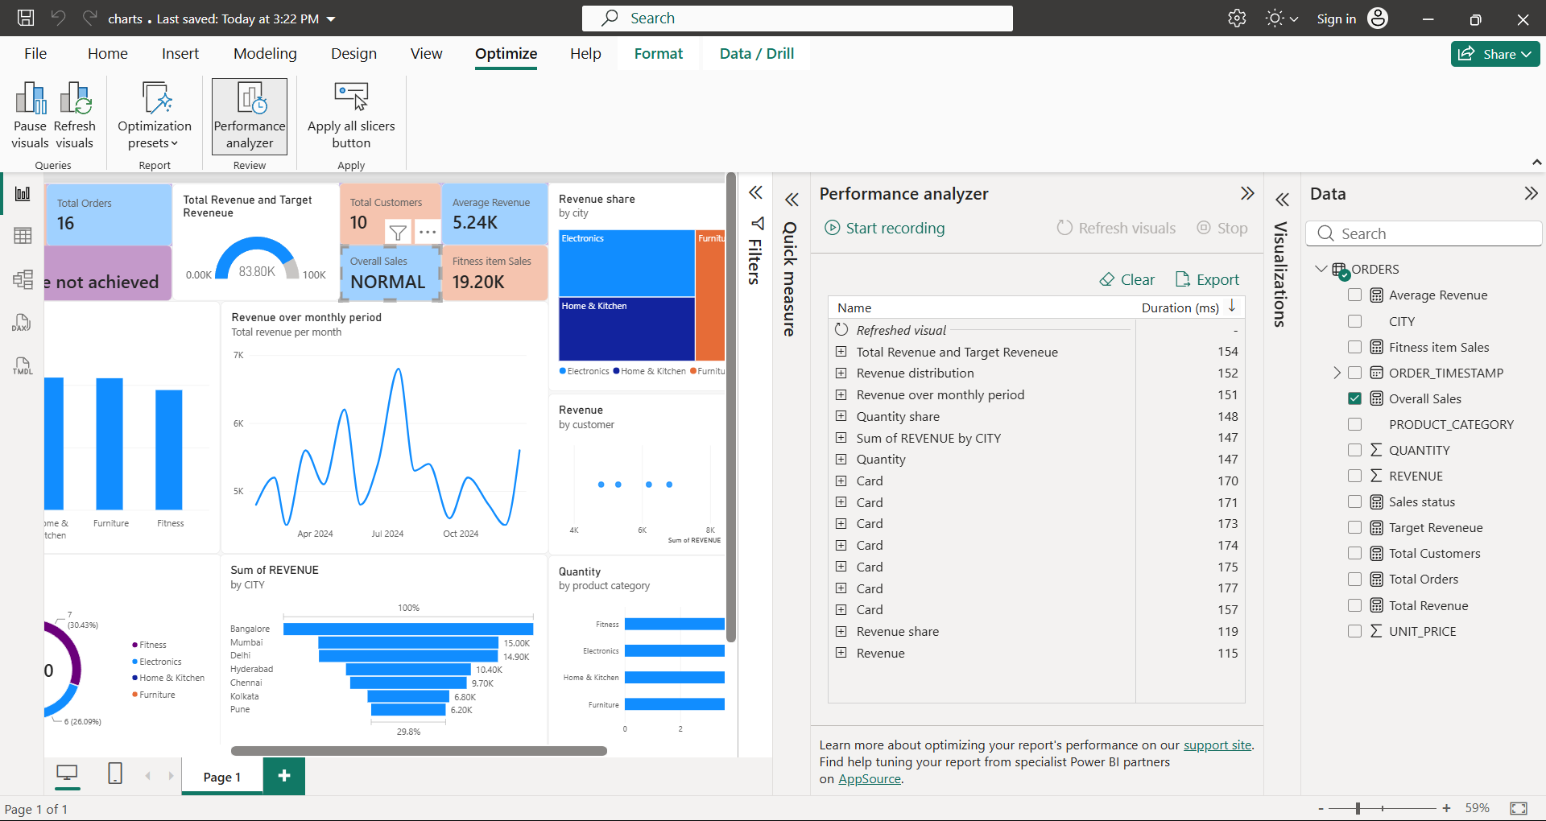
After optimization, clear the previous analyzed result by clicking on ‘clear’ button. Then once again run the analyzer and view results. Now the same card took 175 ms to be calculated and rendered.

